**Steps for connecting Master Jenkins to agent Jenkins server!**

On master node enter into cd .shh directory,

Generate ssh-keygen key … your generated key will be unique!!!

Press enter for every prompt (3x enter)

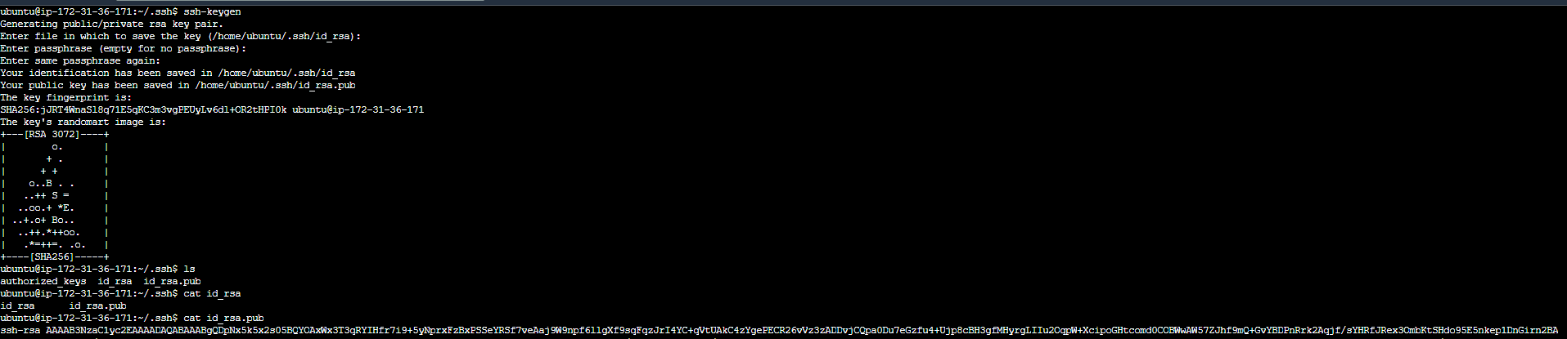

Lets open our agent server instance & copy public key from master to authorized_keys file.

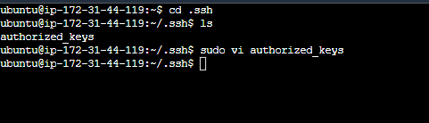

Copy-pasted public key of master to agent

Lets try to ssh agent server from master using , ssh <usernameofagent>@<ip-addressofagent>

It will ask regarding fingerprint ..kind type yes … (not shown in below screenshot as I have already ssh that instance before)

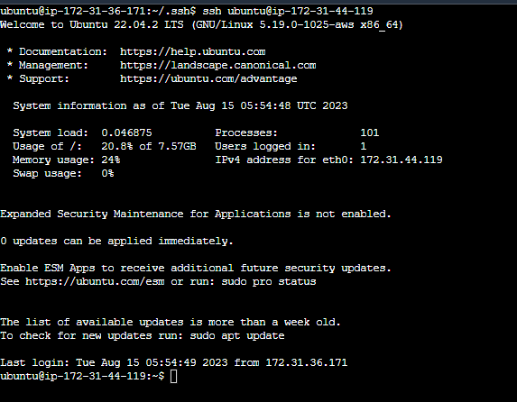

We successfully connected our master server to agent server via ssh!!